
COLLEGE OF COMPUTING AND INFORMATION SCIENCES
DEPARTMENT OF NETWORKS
BACHELOR OF SCIENCE IN SOFTWARE ENGINEERING (YEAR 2) RECESS TERM 2 (BSE 2301)

SOFTWARE PROJECT REPORT FOR:
GRAMMAR AND ONLINE PRODUCT REVIEWS
GROUP 8

Name | Student Number | Registration number
Kimwero Dickson | 216000635 | 16/U/441
Lumala David | 216003711 | 16/U/6679/eve

Table of Contents
1. Introduction 4
1.1 Purpose of this document 4
1.2 Intended Audience 4
1.3 Scope 4
1.4 Definitions and acronyms 4
1.4.1 Definitions 4
1.4.2 Acronyms and abbreviations 4
1.5 References 4
2. Background and Objectives 5
2.1 Objectives 5
3. Organization 5
3.1 Project Manager 5
3.2 Project Group 5
3.3 Steering Group 5
3.4 Customer 5
3.5 Others 6
4. Milestones 6
4.1 Remarks 6
5. Project Results 7
5.1 Requirements 7
5.1.1 Requirement Compliance Matrix 7
5.1.2 Requirements Compliance Summary 7
5.2 Work Products and Deliverables 8
6. Project Experiences 8
6.1 Positive Experiences 8
6.2 Improvement Possibilities 8
7. Financials 8
7.1 Project Cost Summary 8
8. Metrics 9
8.1 Milestone Metrics 9
8.2 Problems 9

TABLE OF FIGURES
Figure 1: Upload Data 7
Figure 2: Grammar analysis 7
Figure 3: Spelling check 8
Figure 4: Punctuation Analysis 8
Figure 5: Punctuations 9
Figure 6: Sentimental analysis 9
Figure 7: Visualization 10

Introduction
This report summarizes all the primary statistical modeling and analysis results associated with the Grammar and online product reviews study. The purpose of this report is to document both the implemented system and project members’ experience while implementing the project.

Purpose of this document
This PR document will specify the project description and all team member experience while developing the system and documents required. It will include the problems faced by team members and costs incurred while developing the Grammar and online product review system.

Intended Audience
The intended audiences of this project are researchers, project team members, Product manufacturers, Product reviewers, documentation writers, marketing staff and users involved in the datafiniti database.

Scope
The project is a data analysis system that analyzes reviews from different products online. The project is aimed at providing clear visualized insights that will help users come up with predictions and make good decisions for future progress.

Definitions and acronyms

Definitions
Keyword | Definitions
Visualization | Graphical representation of a insights from analysis
Sentimental analysis | Tracking emotion scores on the product reviews
Project | The whole system developed

Acronyms and abbreviations
Acronym or  abbreviation | Definitions
PR | Project report
CPU | Central processing unit
RAM | Random Access Memory
SDD | Software design document
SRS | Software requirement specification
GOPR | Grammar and online review

References
[1] Davis M A, “Just Enough Requirements Management: Where Software Development Meets Marketing”, New York, Dorset House Publishing, 2005.
[2] Gary_B._Shelly, _Harry_J._Rosenblatt] _Systems_Analysis (BookFi.org)
[3] Final_Report_dan.pdf report template

Background and Objectives
The Grammar and online review system is developed to perform analysis, get insights, visualize the insights and make clear predictions and conclusions. This document will the description of the main functions of the system and how the user can interact with the system.

Objectives
- Analyzing how the number of spelling errors differ by rating
- Showing frequency of words with spelling errors and review length differ by rating
- Showing the number of reviews that don’t end with punctuations and proportion of reviews with spelling errors.
- Analyzing the distribution of star ratings across products and how long a typical review is.
- To visualize all insights from the analysis made by the system for easy interpretation by the user.
- Perform a sentimental analysis on the product reviews.

Organization

Project Manager
Kimwero Dickson is the Manager of the group.

Project Group
Name | Responsibility
Kimwero Dickson | Project manager, Analysis, Implementation, Designing
Lumala david | Implementation, Documentation, Analysis

Steering Group
- Mbabazi isaac
- Kange Noah

Customer
Product manufacturers, product reviewer and other users

Others

Milestones
Id | Milestone  Description | Responsible Dept./Initials | Finished week |  |  |  | Metr | Rem
Id | Milestone  Description | Responsible Dept./Initials | Plan | Forecast |  | Actual | Metr | Rem
 |  |  |  | Week | +/- | Actual | Metr | Rem
M-001 | Concept Paper | All team members | 13-06-18 | 1 | 0 | 13-06-18 | Y | Good
M-002 | SRS | All team members | 20-06-18 | 2 | 0 | 20-06-18 | Y | Good
M-004 | SDD | All team members | 27-06-18 | 3 | 0 | 27-06-18 | Y | Excellent
M-005 | User interface design | Kimwero Dickson | 04-07-18 | 4 | 0 | 04-07-18 | Y | Good
M-006 | Functions implementation | All team members | 11-07-18 | 5 | 0 | 11-07-18 | Y | Good
M-007 | Project report | All team members | 18-07-18 | 6 | 0 | 19-07-18
M-008 | Final Presentation & delivery | All team members | 25-07-18 | 7 | 0 | 25-07-18 | Y | Good

Remarks
Remark Id | Description
R-001 | It was good experience to work as a team
R-002 | It was fun working with Mr. Mbabazi Isaac as our project supervisor.
R-003 | We believe we have what it takes to qualify as data analysts

Project Results

Requirements

Requirement Compliance Matrix

Id | Requirement  Description | completed
REQ-1 | User should be able to upload datasets for analysis. | Yes
REQ-2 | The system should display the imported data immediately after dataset upload. | Yes
REQ-3 | The system should analyze the grammar for the product reviews. | Yes
REQ-4 | The system should analyze the punctuation for the product reviews. | Yes
REQ-5 | The system should visualize the insights got from the analysis. | Yes
REQ-6 | The system should display graphs and conclusions from the analysis. | Yes
REQ-7 | The system should perform a sentimental analysis on the product reviews. | Yes
REQ-8 | Users should be able to control the scale of graphs displayed on the system. | Yes

Completed: Yes (completely implemented)
No (not implemented at all)
Partially (partially implemented, more description under Remarks subsection)
Unknown (completion status not known)
Dropped (requirement was dropped during the course of the project)

Requirements Compliance Summary

Total number of requirements | 8
Number of requirements implemented | 8
Requirements partially fulfilled | 0
Requirements not fulfilled | 0
Requirements dropped | 0

Screenshots for implemented functionalities

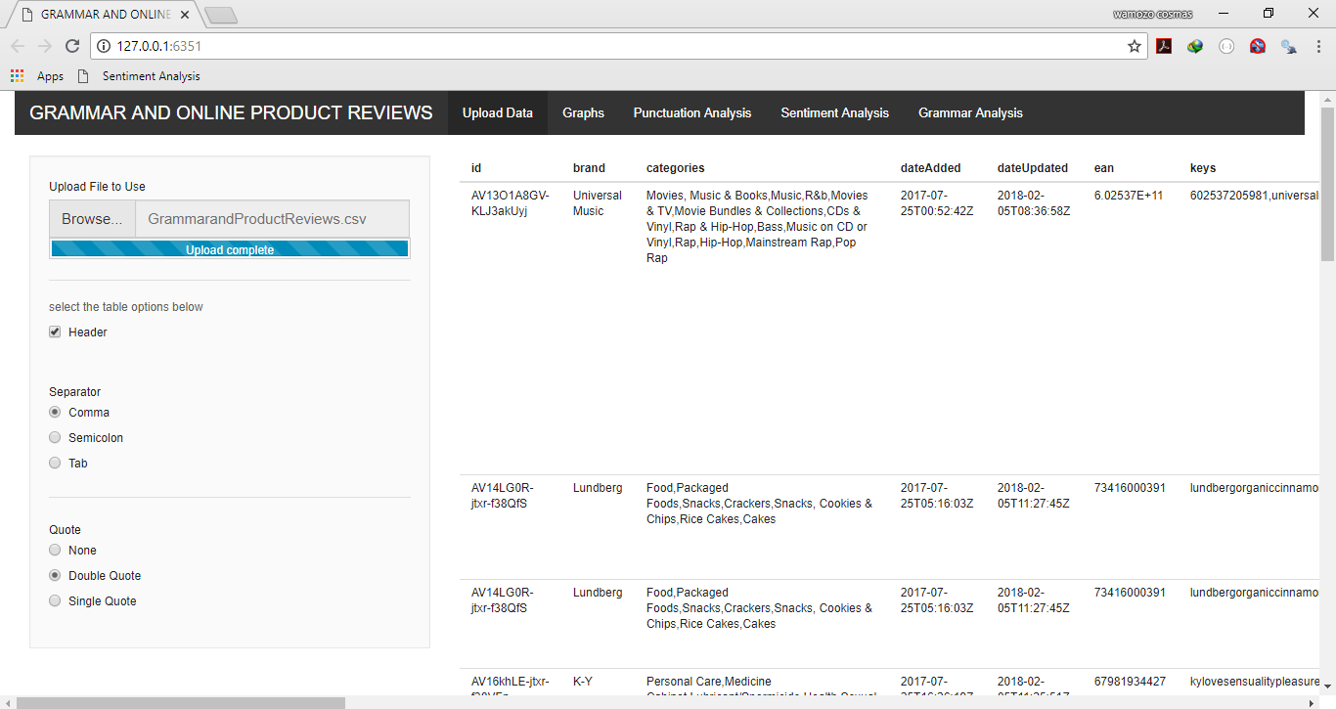
Figure 1: Upload Data
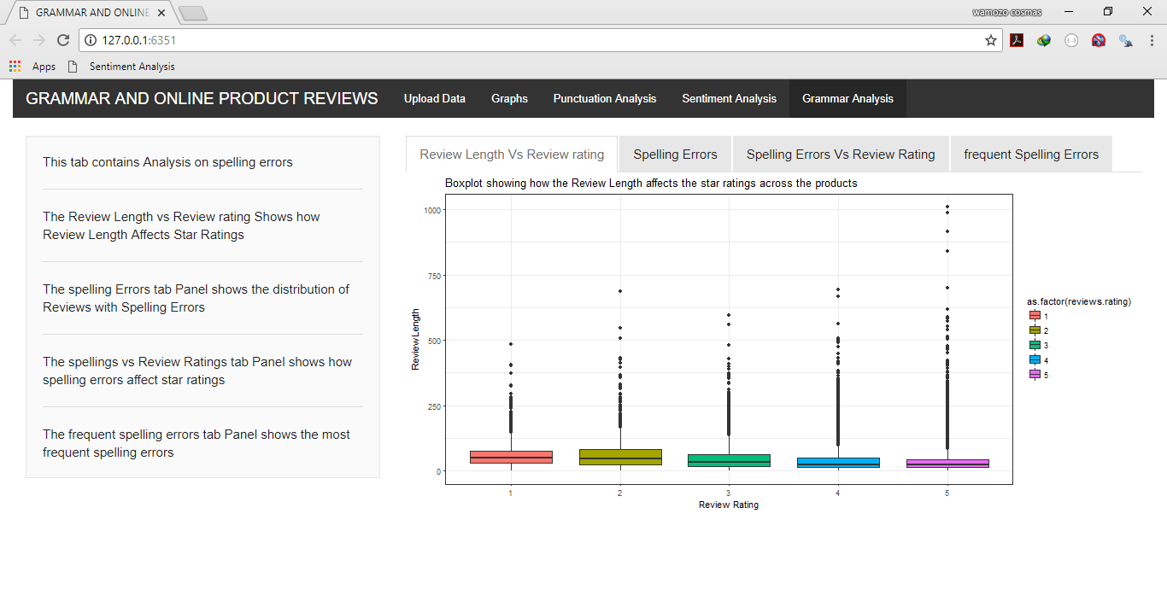
Figure 2: Grammar analysis
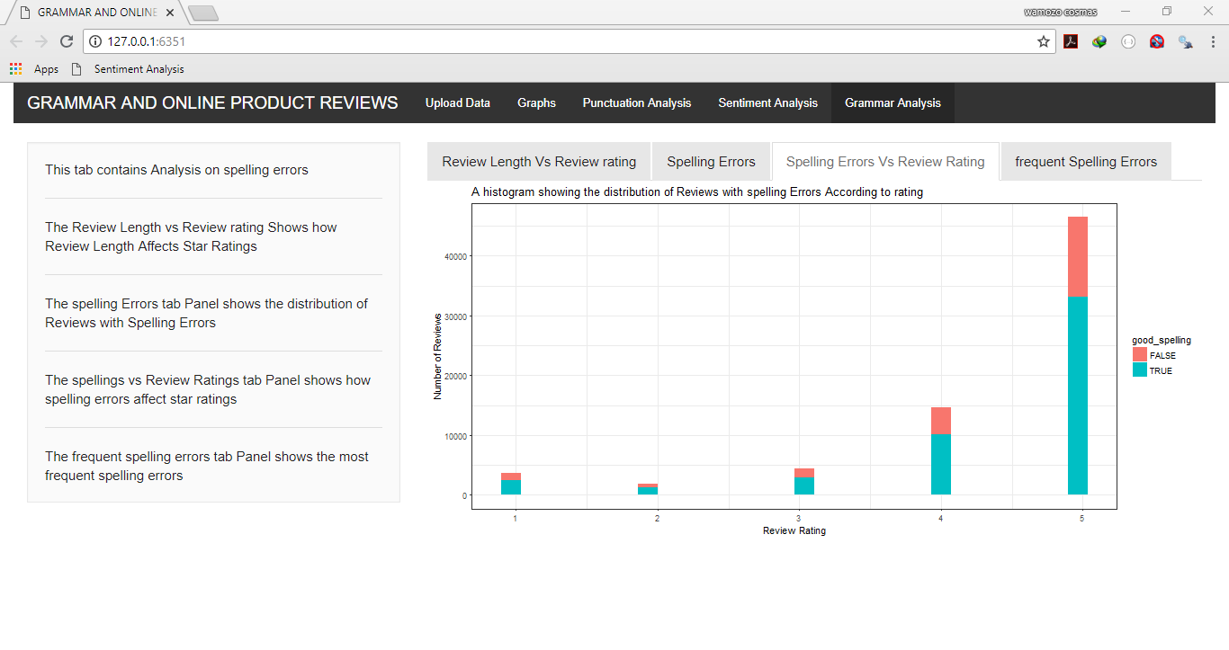
Figure 3: Spelling check
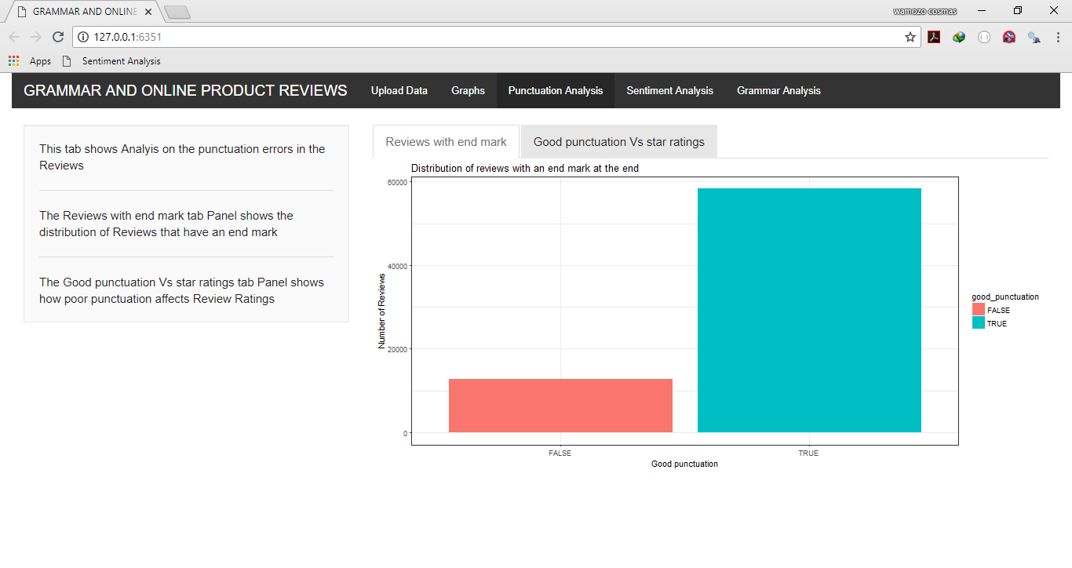
Figure 4: Punctuation Analysis
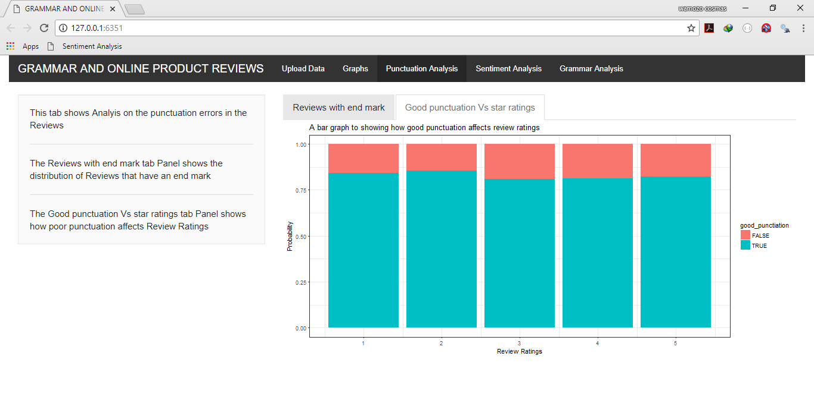
Figure 5: Punctuations
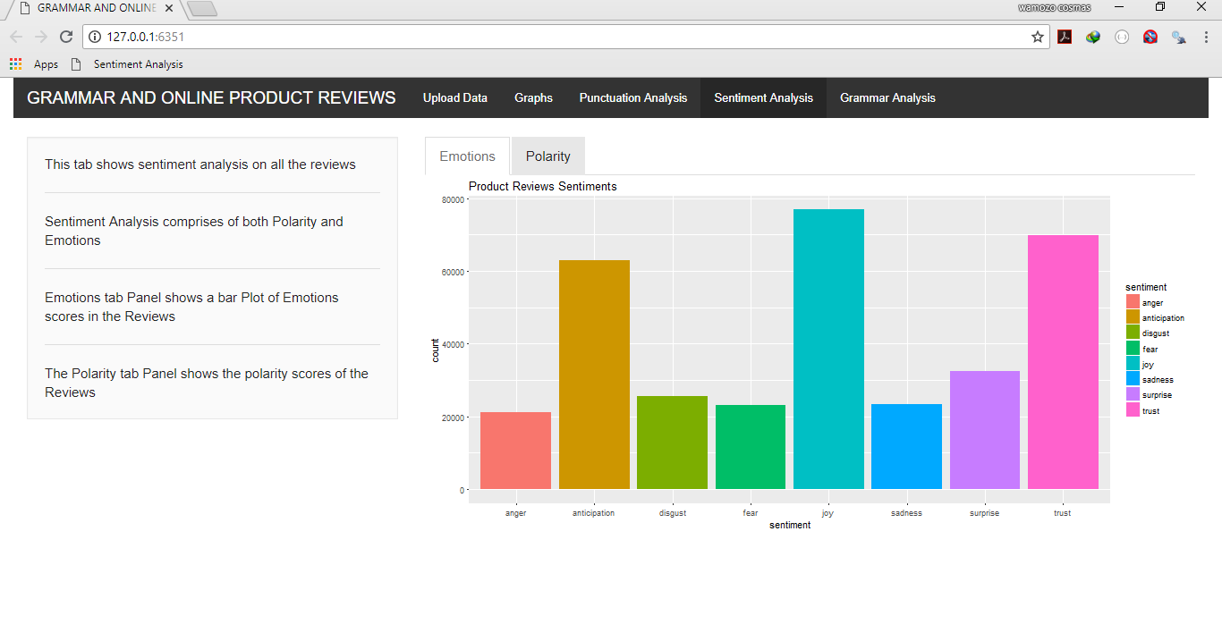

Figure 6: Sentimental analysis
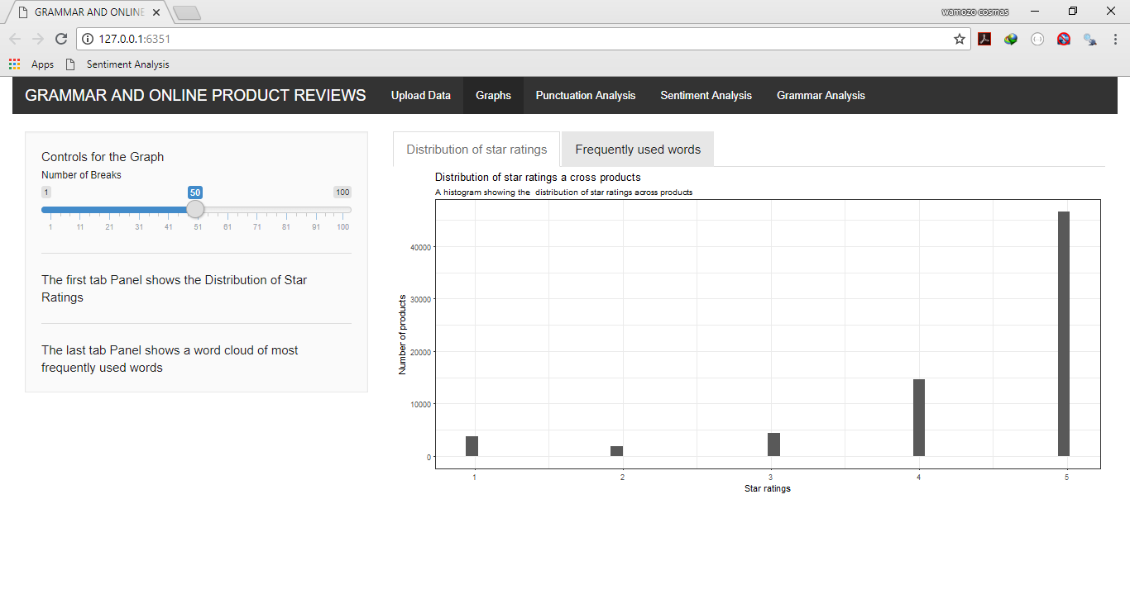
Figure 7: Visualization

Work Products and Deliverables

To | Output | Planned week | Promised week | Late +/- | Delivered week
Supervisor | Concept Paper | W1 | W2 | No | W1
Supervisor | SRS | W2 | W2 | No | W2
Supervisor | SDD | W3 | W3 | No | W3
Supervisor | User interface design | W4 | W4 | yes | W5
Supervisor | Functions implementation | W5 | W5 | yes | W6
Supervising  Panel | Project report | W6 | W6 | No | W6

Project Experiences

Positive Experiences
We learnt how to work in groups and organize ourselves as a team.
We gained experience in data analysis.
We learnt to work on a schedule and make sure we meet the deadlines.
We learnt the IEEE documentation standards.
We gained more experience on how to use the internet for diverse research.

Improvement Possibilities
The project team members hope to improve on their approach about data analysis projects by making sure they interpret the project as it’s supposed to be.
We hope to improve our skills on requirements collection.

Financials

Project Cost Summary
Resource | Cost(shs)
Photocopy fees | 15000
Internet costs | 40000
Compact disks | 2000

Metrics

Milestone Metrics

Completed as planned or earlier | Total | Timeliness
7 | 7 | Achieved

Problems
- The system required to download a lot of packages that were not embedded in R studio.
- High internet costs since the system required a lot of online research.
- The time span for the project was not enough hence inducing pressure on the team members.
- Incompatible R packages with the R studio version used hence increasing workload.
- Huge dataset that takes long to respond to some analysis like sentimental analysis.

